Technology in the Music Classroom Lesson Plan Assignments
Name Phillis Bunch Lesson Plan Type Responding

Lesson title: WOW! Is That John Williams?
Class/Grade: Grade 4
Standards: TEKS Addressed
4.1 Perception. The student describes and analyzes musical sound and demonstrates musical artistry. The student is expected to:
(A) Categorize a variety of musical sounds, including children's and adults' voices; woodwind, brass, string, percussion, keyboard, and electronic instruments; and instruments of various cultures;
(B) Use standard terminology in explaining music, music notation, musical instruments and voices, and musical performances;
4.6 Response/evaluation. The student responds to and evaluates music and musical performance. The student is expected to:
(A) Apply basic criteria in evaluating musical performances and compositions;
(B) Justify, using music terminology, personal preferences for specific music works and styles;
NETS-S Addressed:
- Basic Operations and Concepts Students: a. demonstrate a sound understanding of the nature and operation of technology systems. b. are proficient in the use of technology.
- Technology Productivity Tools Students: a. use technology tools to enhance learning, increase productivity, and promote creativity. b. use productivity tools to collaborate in constructing technology-enhanced models, preparing publications, and producing other creative works.
21st Century Skills Addressed:
- Learning and Innovation Skills Learning and innovation skills are what separate students who are prepared for increasingly complex life and work environments in today’s world and those who are not. They include: • Creativity and Innovation • Critical Thinking and Problem Solving • Communication • Collaboration
National Standards Addressed:
- MU: Pr4.3.4a Demonstrate and explain how intent is conveyed through interpretive decisions and expressive qualities (such as dynamics, tempo, and timbre).
- MU: Re8.1.4a Demonstrate and explain how the expressive qualities (such as dynamics, tempo, and timbre) are used in performers’ and personal interpretations to reflect expressive intent.
- MU: Re9.1.4a Evaluate musical works and performances, applying established criteria, and explain appropriateness to the context.

Learning Outcomes: Students will complete a foldable on music composed by John Williams and discuss, using proper terminology, their preference for or against the piece that is played.
Assessment Evidence: The students will complete a foldable with correct music terminology to assess proper musical vocabulary. The foldable will be graded and returned to the student the following week. Students will also share their ratings of the music via the iPad Classflow Connect to the Promethean Board for an overall class rating of the piece followed by a (teacher directed) class discussion. (Refer to the question prompts.)
Prior Knowledge and Skills: Students have been practicing using correct music vocabulary for several weeks and have also completed a foldable over the Composer John Williams. They have researched the different movie scores that John Williams has composed and are now ready to discuss particular pieces that he has composed. Vocabulary will be reviewed using Quizlet. There is also a hard copy of this entire lesson in the big blue box labeled “SUB BOX” found on the table in the back of the room! (Sometimes the internet and school network doesn’t like the Annex!)
Students will also review iPad rules and use polices. Students have been using iPads in all of their classes and have already used them in the music class. The “Technology student” has been trained to export materials to the student iPads for substitutes who are not proficient with the Promethean Board or iPads.
Materials: Promethean Board, computer, teacher iPad, student iPads (cart of 30 from the library), Vocabulary review (https://quizlet.com/phillismarie/folders/response-to-music-vocabulary ) Word Wall (Located on the west wall of the classroom), MP3 of John Williams “The Imperial March Live 2014” and MP3 of the “Jurassic Park Theme” ( Located in the John Williams Folder on the desk top and on the iPod if needed), Videos: John Williams “The Imperial March Live 2014” (https://www.youtube.com/watch?v=OvsJk6Dve3A ) The Piano Guys “Cello Wars”: (https://www.youtube.com/watch?v=BgAlQuqzl8o ) (Both Videos are also downloaded in the John Williams Folder on the desktop.) Copies of the Foldable (Also included below), Pencils, Glue sticks, scissors, map pencils, Classflow Connect (https://classflow.com )
(The directions and picture to make sure that the box on the back of the Promethean Board is located on the docking station at the front of the classroom.) Classflow Connect uses HDMI 4 and USB touch switcher 1 (on the back of the panel)
Learning Activities:
- As students enter the music room, the student helper will pass out student iPads.
(Students will use the iPads later in the class period so they need to set the iPads on the table in front of them. They are not allowed to play with the iPads during the lecture.)
- The students will have a seat at the tables facing the Promethean Board. There should be a set of pencils, scissors, glue sticks, and map pencils at each table.
- Have the student helper pass out both parts of the John Williams Music Foldable.
The students will FIRST put their name on the Foldable and then glue the two pieces of the foldable together (where it says “Glue Here”) and cut the flaps to create the tabs. (The students made this same type of foldable last week and should be able to perform this task with minimal intervention. If a student was absent or needs help, pair them with the student helper.)
- Teacher is to walk around the room to ensure that students remain on task. (Actively monitor)
- Once the students have assembled the foldable, have them clean up glue and scissors and return the items to the container on each table. The students will need to have a pencil and be prepared to listen.
- Launch the Vocabulary Review via Quizlet (The technology helper can perform this task.) (https://quizlet.com/phillismarie/folders/response-to-music-vocabulary)
- As a class goes through each flashcard to review possible terms to be used while filling out the foldable.
- Remind the students that they will be listening for specific things such as tempo and dynamics. Direct the students to the vocabulary Word Wall to their right in the classroom. (West wall)
- Instruct the students to fill out the Title as “The Imperial March”
- Play the MP3 of John Williams’ “The Imperial March Live 2014” ( located in the John Williams folder on the desktop or on the classroom iPod for emergencies)
- Have the students LISTEN to the recording and fill out the Foldable using a pencil. (The “Notes” section is on the front of the foldable will be used if they need to remember something for the discussion.)
- After the students have listened to the MP3 and filled out the foldable, instruct them to put the pencils in the containers on the table and select a map pencil for the next part of the activity.
- Now launch the video of John Williams’ “The Imperial March Live 2014” (https://www.youtube.com/watch?v=OvsJk6Dve3A)
- Have the students watch the video and add (in map pencil) details that they may have overlooked.
- Have the students turn on the student iPads and go to Classflow Connect.
- Teacher (or student technology helper) will launch Classflow Connect (https://classflow.com/classflow/) and mirror the teacher iPad to the Promethean Board. In the Class tab, launch (DELIVER) the Assessment/Response John Williams class.
Have students enter the 5 letter code to connect to the appropriate class (Example: QWXRL) found in the top right side of the Promethean Board.
- Have the students “Rate” the piece 1-5 stars on their Foldable and on the iPads. The
student rating will be sent to Classflow Connect and they should also discuss how the
music made them feel in the comments section of the assessment. (This information will
used in addition to the foldable for the grade on this activity.)
- Discuss the ratings as a class. The ratings will be projected on the Promethean board and the following questions can be used as prompts:
        - How many of you had heard this piece before?
        - How many of you have seen the movie? What is the name of the movie/movies?
        - Is this the only piece of music from the movie or are there others?
        - Does anyone know the title of another piece of music from this movie?
- Now let’s watch another video to compare with “The Imperial March. 2014 Live”
- Play the Piano Guys “Cello Wars” (https://www.youtube.com/watch?v=BgAlQuqzl8o)
(Also found in the John Williams folder on the desktop.)
- Now let’s compare and contrast the two videos:
        - Which one did you like the most?
        - What was different about the sound of the two pieces?
        - Are they the same piece?
        - Do you know any other movie music composed by John Williams?
- Next week we will conclude our discussion about John Williams by listening to a piece
of music from the movie Jurassic Park… play the MP3 (found in the John Williams folder
on the desktop and on the classroom iPod) of the theme from Jurassic Park
(https://www.youtube.com/watch?v=D8zlUUrFK-M ) as the students put away the iPads
(by table) and line up to leave.

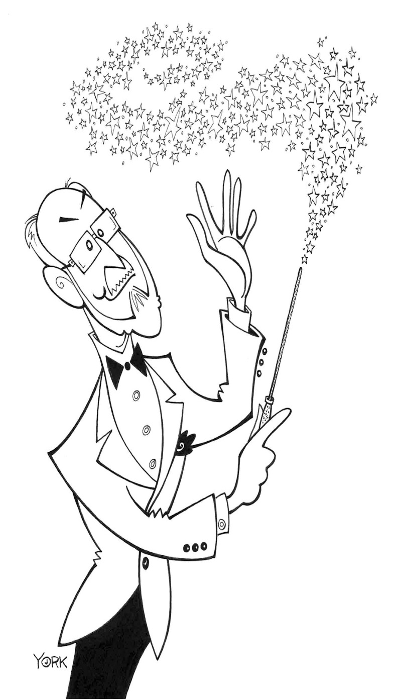  NOTES for discussion:  Rate this piece here: | Title  Make sure to use capital letters and correct punctuation for a Song Title!
Instruments
that
I
Hear
Not Just the Family!
Tempo
Does the piece speed up or slow down?
Use proper music terminology!
Dynamics
More than just soft or loud!!!
Write the entire word.
pp,p,mp,m,mf,f,ff
Are there Crescendos?
Glue Here

