Technology in the Music Classroom Lesson Plan Assignments

Name: Phil Rumbley Lesson Plan Type: Creating, Performing, Responding
Lesson Title: Performance of Hot Cross Buns with varied expression markings
Class/Grade: Sixth Grade Band
Standards: The standards that align with this lesson are perception and creative expression/performance. These standards are TEKS music standards Level I; (A) identify melodic and harmonic parts when listening to and/or performing music; read and write music that incorporates rhythmic patterns in simple, compound, and asymmetric meters; and(C) interpret music symbols and terms referring to dynamics, tempo, and articulation during solo and ensemble performances.
Learning Outcomes: At the conclusion of this lesson, students will be able to perform Hot Cross Buns with an understanding of p, mf, f dynamic markings. Students will be able to utilize these dynamic markings in future rehearsals and performance. Students will also have better awareness of playing in tempo within the entire ensemble.
Assessment Evidence: Assessment evidence will be revealed by the students understanding of these dynamic markings and the readings taken by a decibel meter that indicate the change in sound levels when the ensemble plays at different volume levels.
Prior Knowledge and Skills: Sixth Grade Band students who participate in this lesson must know on their specific instruments the correct fingerings, positions and knowledge of concert pitches Bb, C and D. Students should also have knowledge of playing a whole note, half note and quarter note. Students should also be knowledgeable of the 4/4 time signature. Students should know how make adjustments on their instruments if they are not in tune.
Materials: For the successful completion of this lesson, materials needed are a desktop PC or Macintosh computer and a Macintosh iPad. The iPad must have the apps; Decibel Meter Pro https://itunes.apple.com/us/app/decibel-meter-pro/id382776256?mt=8 as well as the Tonal Energy Pro app https://itunes.apple.com/us/app/tonalenergy-chromatic-tuner/id497716362?mt=8 A laser jet printer is needed to print out previously notated music with new dynamic markings from Finale notation software. http://www.finalemusic.com/ Paper and pencil is needed to write down decibel level readings while students are playing. Printed music of Hot Cross Buns (example at bottom of lesson plan) that includes the added dynamic markings. General set up for sixth grade band in band hall (chairs and stands). Edirol recording and playback device. http://www.rolandus.com/products/r-09/ A CD player to play a pre-recorded piano accompaniment of Hot Cross Buns. CD that has the piano accompaniment of Hot Cross Buns.

Learning Activities:
- Students will enter the band hall, assemble their instruments and individually check their tuning playing concert Bb using the Tonal Energy app that is loaded on an iPad located at the front of the band hall. The “green smiley face” is the indicator that they are in tune.
- With the director, students will review whole notes, half notes and quarter notes playing concert pitches Bb, C and D in no specific order. This review will be done using the Tonal Energy metronome setting.
- Students will be introduced to dynamic markings p piano, mf mezzo forte and f forte and proper air stream to accomplish correct playing of these dynamics.
- Students will demonstrate their understanding of these dynamic markings by playing a concert Bb whole note using all three of these dynamic markings. An assigned student will record the decibel level of each dynamic marking on paper using the decibel level reading device.
- Students will be given a copy of Hot Cross Buns that includes specified dynamic markings (example below) that have been previously discussed and understood by all students.
- Students will play Hot Cross Buns in its entirety with the pre-recorded piano accompaniment using only the mf dynamic marking. This will be rehearsed several times to make sure that all students play rhythms and notes correctly. The Tonal Energy metronome app will be used during this time with a setting of 90 bpm.
- At this time students will play Hot Cross Buns (with accompaniment) utilizing the dynamic markings on the music. This will be recorded on the Edirol device. A assigned student will record the decibel level reading for each dynamic marking change. This will be played without the metronome.
- A comparison of decibel level readings will be made at this time comparing the levels when students played concert Bb whole notes earlier, to the playing of Hot Cross Buns utilizing the dynamic markings.
- Students will listen to the recording to hear the dynamic changes made while playing.
- Should students feel over exaggerations were made in playing these dynamics, they will play the piece again until students agree on appropriate playing of the dynamics.
- Final agreement of the dynamics will be followed by a performance of Hot Cross Buns with varied expression markings (with piano accompaniment and no metronome)
*It should be noted that students should not feel restricted to the decibel level readings that were made that constitutes a certain dynamic, but they should become more aware and knowledgeable of proper use of dynamics in the future when playing longer pieces of music that include these dynamic markings. Using a decibel level device makes it more fun for young musicians. An additional app that can be implemented in this lesson plan is the oscillator app that shows sound waves. https://itunes.apple.com/us/app/oscilloscope/id388636804?mt=8

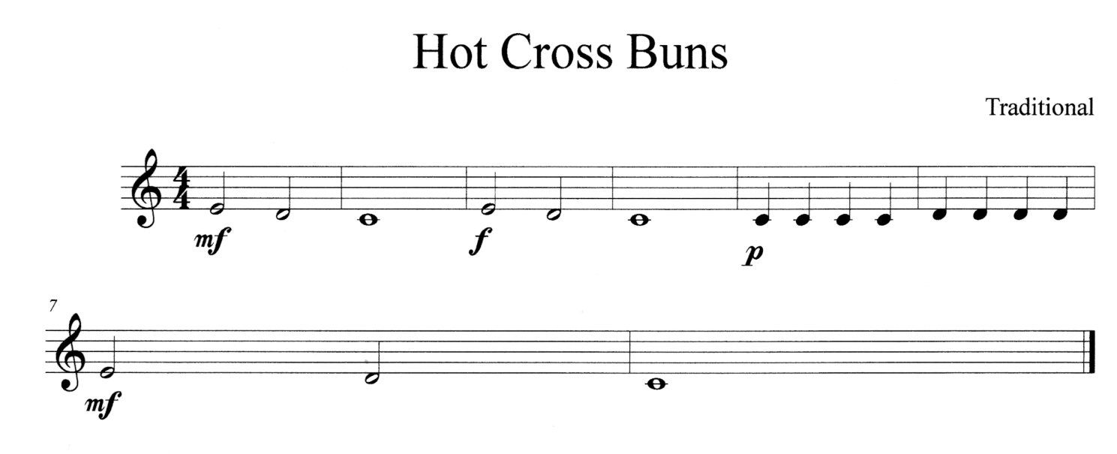
*Music for Hot Cross Buns with dynamic markings for performance of sixth grade band.

