Technology in the Music Classroom Lesson Plan Assignments
Name: Sherry Marshall
Lesson Plan Type: Responding to music lesson

Lesson title: Music Time Line Lesson
Class/Grade: 5th Grade music classes
Standards: TEKS – 5th Grade Music; NAFME National Music Technology Standards
- TEKS 1(B) – Use standard terminology in explaining music, music notation, musical instruments and voices, and musical performances
- TEKS 5(A) – Identify aurally-presented excerpts of music representing diverse genres, styles, periods, and cultures
- TEKS 5(E) – Identify concepts taught in the other fine arts and their relationships to music concepts
- TEKS 6(A) – Apply criteria in evaluating musical performances and compositions
- TEKS 6(B) – Evaluate, using music terminology, personal preferences for specific music works and styles
- NAFME CA9 – The Personal evaluation of musical works and performances is informed by analysis, interpretation, and established criteria
- NAFME CA10 – Musicians connect their personal interests, experiences, ideas, and knowledge to creating, performing, and responding.
Learning Outcomes: Student will be able to identify characteristics of music from different musical periods. Students will be able to place composers within a time line based on their music and characteristics of their time period.
Assessment Evidence: Student outcome will be graded through an online quiz using Google Forms in class.
Prior Knowledge and Skills: Students have one on one access to ChromeBooks and familiarity with Google forms. Students have had prior lessons that focus on individual musical time periods through the Quaver Music Curriculum. Students have previously learned the “Musical Periods” song.
Materials:
Teacher: PC and projector with iPad connected through Splashtop. The iPad will also have a playlist containing music clips from all 42 composers for the DSO Time Machine Game.
Students: ChromeBooks – logged in to their school Google account and the Google form quiz for this class period.
Learning Activities: Musical Time Line
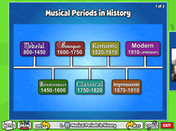
- Log in to Quaver Music 4th Grade Lesson 25 – “Time Line” and play “The Happy Farmer” as students enter. Follow the Quaver lesson plan for slides 2-8:
2 .
Musical Periods in History
1-2 min
- Review the musical periods timeline, paying particular attention to the position of the Romantic period.
- Convey how musical periods are identified - by style, cultural influences, instruments used, noted composers, and so on.
- Keyword: Romantic Period - (1820-1910) A period that emphasized passion, drama, and emotion in music. (Slide 2)
  - Medieval (800 - 1450)
  - Renaissance (1450 - 1600)
  - Baroque (1600 - 1750) (2nd grade)
  - Classical (1750 -1820) (3rd grade)
  - Romantic (1820 -1910) (4th grade)
  - Impressionist (1870 - 1910) (5th grade)
  - Modern (1910 - Present)
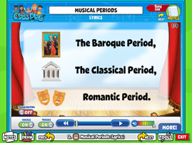
3 .
Musical Periods (Lyrics)
2-3 min
- Sing the Musical Periods song with students to review major time periods.
The Musical Periods score is printed at the end of the Lesson Plan and can be downloaded from the Worksheets.

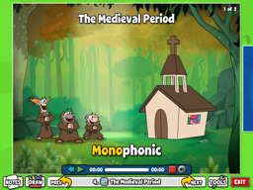
4 .
The Medieval Period
2-3 min
- Explain the use of the words "a cappella," "in the church," and "monophonic."
- Keyword: Medieval Period - A period characterized mainly by music of the church and traveling poet-musicians.
- We use the phrase "a cappella" to mean "without instruments." Its literal meaning is "in the manner of the chapel (church)."
  - Since instruments were not played in most churches, monasteries, or convents, "a cappella" was used to mean "without instruments."
  - Music during the Medieval Period was monophonic, meaning only one voice - the melody.
- PLAY the on-screen track, inviting students to comment on the music.
- As students listen to music in the next four screens, remind them of The Quaver Five principles and how they relate to listening to recorded music.
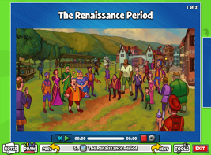
5 .
The Renaissance Period
2-4 min
- Explain that during the Renaissance Period, as music extended beyond the walls of the church to every day life, themes changed from religion exclusively to subjects like nature and people.
- Keyword: Renaissance Period - A period of "rebirth" from 1450-1600 where new experimentation in music, art, and literature took place.
- Convey that the music became polyphonic (more than one sound at a time) as voices other than the melody were sung or played.
- Tell students that poems about people and social situations were set to music and were called "madrigals."
- Listen to the Say, Love, If Ever Thou Didst... track, inviting students to guess how many voices are singing.
- Encourage them to listen to the lyrics to see if they understand what the performers are singing about. Field comments.
- As time permits, have students respond verbally and with movement to the song.
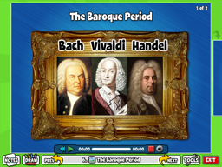
6 .
The Baroque Period
2-4 min
- Ask students to describe the Baroque Period.
- Listen for answers, such as: fancy, use of ornaments (trills, turns, appoggiaturas); wigs; use of the harpsichord; small orchestra with mostly stringed instruments.
- Keyword: Baroque Period - A period of history (1600-1750) that emphasized fancy music, art, fashion, and architecture.
- Discuss the following composers: Bach, Vivaldi, and Handel.
- Listen to Vivaldi's The Four Seasons (Spring) using the on-screen track.
- Invite students to listen for the fancy embellishments and determine which animals those sounds are imitating (birds, wind, and so on).
- As time permits, have students respond verbally and with movement to the song.
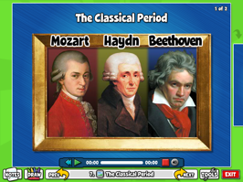
7 .
The Classical Period
2-4 min
- Ask students to describe the Classical Period, listening for words such as: orderly, balanced, more instruments, piano introduced, and the time of American and French Revolutions.
- Keyword: Classical Period - (1750-1820) A period of music that emphasized balance, order, and simplicity.
- Discuss composers: Mozart, Haydn, and Beethoven.
- PLAY Mozart's Eine Kleine Nachtmusik using the on-screen track.
- As time permits, have students respond verbally and with movement to the song.
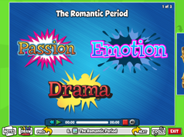
8 .
The Romantic Period
2-4 min
- Keyword: The Romantic Period - (1820-1910) A period that emphasized passion, drama, and emotion in music.
Preview some topics from the Romantic Period:
- What are characteristics of music from the Romantic Period? (emotional, dramatic, passionate)
- Who were some of the famous composers? (Tchaikovsky, Schumann, Brahms, Chopin, Wagner)
- What historical events were going on during the period? (Democratic ideas spread; Marx, Darwin, Freud gained influence; Franco-Prussian war; Mexican-American war; Defeat of Napoleon; First flight of the Wright Bros.)
- How did the orchestra change? (More instruments were added; valves were added to the trumpet; the orchestra seating plan was established.)
- Since Quaver does not cover the modern period in the review, review characteristics of modern music.
- Close Quaver and open the Dallas Symphony Orchestra kids page; Have students open ChromeBooks and log in to their school Google account and locate the Google form quiz for this lesson in their email. The Google form will only have 20 questions/answers, and students will only need to complete what is covered in class.
- Open the “Time Machine” game. Explain the rules of the game. The students will be playing the game on the projector as a class, but they must answer on their own Google Form in addition to playing in class. Open the time line music clip playlist on the iPad.
- Since the DSO game does not include music within the game, the teacher will play the appropriate clip with each composer.
- Students read the composer name, historical tidbit, and listen to the clip. Students will then select the time period in their quiz. After students have answered, they can agree as a class on the correct time period, and the teacher (or a selected student) will choose the period on the game and check the answer.
- At the end of class, students will need to submit their completed forms. These forms will be collected and graded through Google Forms for a daily grade.

