Technology in the Music Classroom Lesson Plan Assignments
Name: Zach Edwards Lesson Plan Type: Creating

Lesson title: Creating an Ostinato Accompaniment with Technology
Class/Grade: Fourth Grade Music Class
Standards: TEKS
4.1c. use known music symbols and terminology referring to rhythm; melody; timbre; form; tempo; dynamics, including crescendo and decrescendo; and articulation, including staccato and legato, to explain musical sounds presented aurally
4.2a. read, write, and reproduce rhythmic patterns using standard notation, including separated eighth notes, eighth- and sixteenth-note combinations, dotted half note, and previously learned note values in 2/4, 4/4, and 3/4 meters as appropriate
4.3a. sing and play classroom instruments with accurate intonation and rhythm, independently or in groups
4.3b. sing or play a varied repertoire of music such as American and Texan folk songs and folk songs representative of local cultures, independently or in groups
4.3e. perform simple part work, including rhythmic and melodic ostinati, derived from known repertoire
4.4a. create rhythmic phrases through improvisation or composition
4.4c. create simple accompaniments through improvisation or composition
4.6a. exhibit audience etiquette during live and recorded performances
4.6e. describe a variety of compositions and formal or informal musical performances using specific music vocabulary

Learning Outcomes:
- Students will use to technology to create an ostinato using known rhythms.
- Students will, in small groups, sing “Yangtze Boatman’s Chantey” while performing ostinato accompaniment on unpitched percussion instruments.
Assessment Evidence:
- Following completion of the learning activities, students will turn in completed worksheets for their musical creations to be assessed by the teacher.
- Student performance will be informally assessed during small group performances.
Prior Knowledge and Skills:
- Known rhythms to be used in this lessons: qsdwxxxc sxdxcd
  - Rhythms will be reviewed and practiced during rhythmic warmup/game and during intial song practice.
Materials:
- Promethean board
- Prezi.com
- Rhythm Wars: Poison Game xcd(m4v file)
- Pencils
- Worksheets (as described in Learning Activities)
- ActiveInspire
- Assorted unpitched percussion instruments
- “Yangtze Boatman’s Chantey” (American Methodology, p. 408)
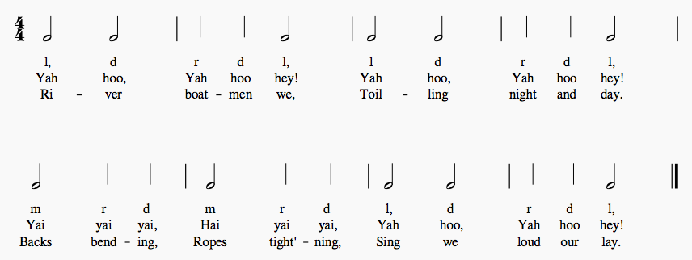
Learning Activities:
- Rhythm Warmup/Practice
  - Show video on Promethean board: Rhythm Wars: Poison Game xcd
    - Students clap and say rhythms as they move across the screen, but are silent during poison rhythm.
- Yangtze Boatman’s Chantey
  - Perform vocal warmup consisting of sirens and known solfege.
  - Sing “Yangtze Boatman’s Chantey” while patting steady beat, then while tapping the rhythm.
  - Students stand and move in general space, stepping to the beat and tapping the rhythm.
  - Teacher displays first slide of Prezi presentation that has different four beat rhythmic patterns on each slide.
    - Class steps to the beat while singing and tapping the rhythm on the board as an ostinato. After each repetition, the class freezes. A new rhythm is put on the board and the class repeats activity with a new ostinato.
- Rhythmic Composition: Ostinato
  - Display ActivInspire presentation with three two-line staves and known rhythmic values at the bottom.
  - Individual students come up to the board to drag and drop rhythms onto each staff to create three four-beat ostinati.
  - Class practices tapping each ostinato while singing “Yangtze Boatman’s Chantey.”
- Group Work
  - Number students off to create groups of four.
  - Each group is evenly assigned two different unpitched percussion instruments.
    - Example: One group of four may be given two tambourines and two pairs of rhythm sticks. Another may be given two egg shakers and two frame drums, etc.
  - Each group is given a worksheet and pencil.
    - Worksheets have one 4/4 measure with a two line staff. Two the left of each line is a space where students will write what instrument is to play each line.
  - Students work in their groups to decide which ostinato their group wants to play, and they copy it onto their worksheets. Students then decide which instrument they want to play each line.
  - Students work in groups to practice their ostinato with instruments, as written on their worksheets. Students should first be able to perform ostinato while counting, using rhythm syllables, then while singing “Yangtze Boatman’s Chantey.”
  - Groups perform for the class, singing “Yangtze Boatman’s Chantey” while performing their ostinato on unpitched percussion instruments.

